Apktool
- Disassembling resources to nearly original form (including resources.arsc and XMLs)
- Disassemble compiled code into smali files
- Rebuilding decoded resources back to binary APK/JAR
- Organizing and handling APKs that depend on framework resources

Installation
- Download Linux wrapper script (Right click, Save Link As apktool)
- Download apktool-2
- Rename downloaded jar to apktool.jar
- Move both files (apktool.jar & apktool) to /usr/local/bin (root needed)
- Make sure both files are executable (chmod +x)
- Try running apktool via cli

Wrapper link
Apktool link
Note: if you don’t have java see link

Usage
Extraction of an apk file:
apktool d $apk -o $folder

Smali
- Smali is an intermediate language designed to translate dalvik executables (.dex files) into a human-readable format
- Smali files can be rebuilt into dex executables
  - very useful for instrumenting/modifying applications
- The name "smali" is the Icelandic equivalents of "assembler"

Class Representation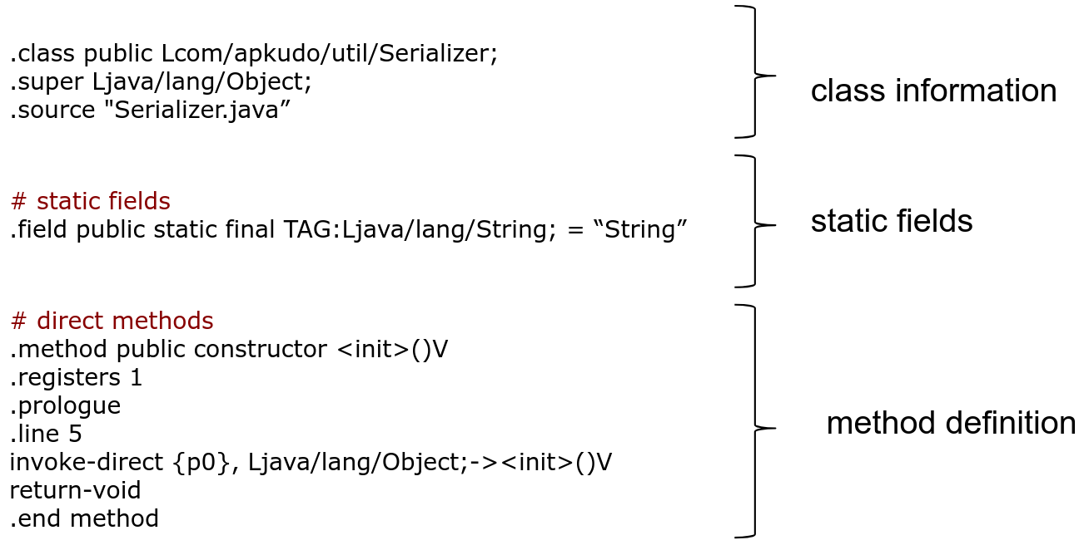

Syntax

Types
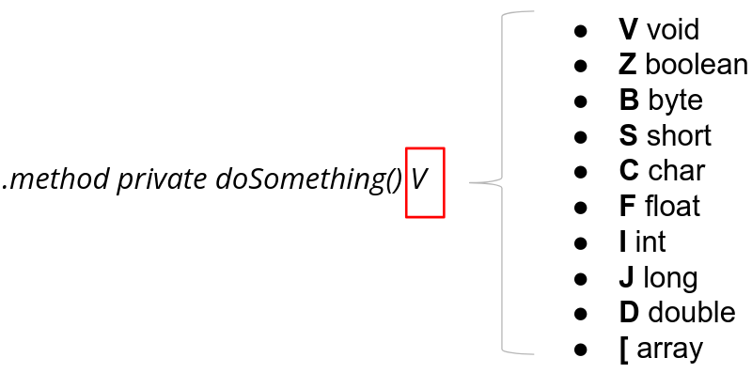

Classes & Methods
Lcom/example/myapp/MyClass;
● full name space slash separated
● Prefixed with a L
● Suffixed with a ;

.method private startFrame (J)Z
25

● keyword (private/public/static..)
● Method name
● Parameters and return value

Method Invocation Opcode
invoke-virtual { parameters }, methodtocall | Invokes a virtual method with parameters.
invoke-super {parameter}, methodtocall | Invokes the virtual method of the immediate parent class.
invoke-direct { parameters }, methodtocall | Invokes a method with parameters without the virtual method resolution
invoke-static {parameters}, methodtocall | Invokes a static method with parameters.
invoke-interface {parameters},methodtocall | Invokes an interface method.

Registers
Dalvik bytecode is register-based
Registers in smali in named using two conventions:
- v# local registers
- p# registers that hold method parameters (p0 : this)
Example:
- v0 local register n. 0
- p0 parameter n.0 (this)
- p1 parameter n.1

Smail Example
StringBuilder sb = new StringBuilder("str");

#Create a new variable and place it in v1 local register
new-instance v1, Ljava/lang/StringBuilder;
#Create a constant string and place it in v2 local register
const-string v2,"str"
#Invoce constructon of StringBuilder with registers v1 and v2
invoke-direct {v1, v2}, Ljava/lang/StringBuilder;-><init>(Ljava/lang/String;)V

Jadx
jadx - Dex to Java decompiler
Command line and GUI tools for produce Java source code from Android Dex and Apk
files

Installation
Download:
- Download latest release from https://github.com/skylot/jadx/releases
- Unzip the package
OR
sudo apt-get install jadx

Usage
In case of source code:
- Open a terminal and move to the jadx bin folder
- Execute jadx-gui

In case of direct install
- execute “jadx-gui” from command line

